IT 327 - Lab #12

Multilevel QAM and PSK

Contents

Objective 2

Procedures 2

Transmitter 2

Receiver 5

Equipment Used 8

Questions 9

Report 9

Conclusion 10

References 11

# Objective

Encode a QAM signal and modulate the signal to a carrier frequency of 100 KHz. Observe the modulated signal, demodulate and decode the signal, compare the original signal with the received signal.

# Procedures

## Transmitter

1. Read lab TIMS manual on the lab website page under Lab 12 (or in the Lab Book D2, starting at pg. 115). Find a block diagram of how to get an mQAM signal. Make sure the wires are connected exactly how it shows on this following diagram otherwise the results will be wrong.

This is a screenshot of the block diagram of how to get an mQAM signal.

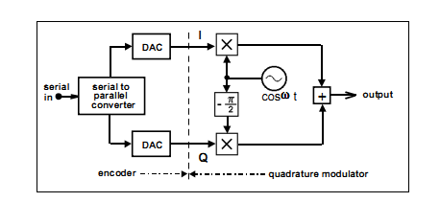

1. Use a sequence generator, m-level encoder, two multipliers, and an adder to modulate a sequence. Gather all the above modules and connect them to TIMS.

This is a screenshot displaying the wiring the cables as to generate a multilevel QAM.

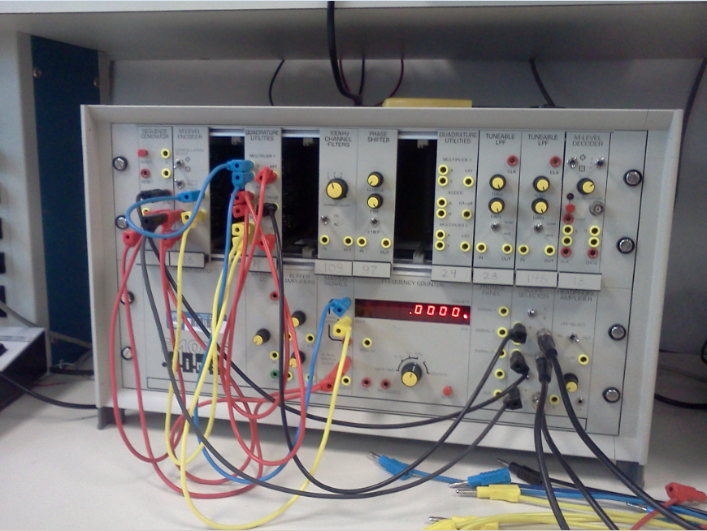

1. Show the original data sequence along with the modulated sequence in both mode YX and mode XY display format. Go to the oscillator device and change the display from XY to YX and vice versa.

This is a screenshot displaying the data sequence along with the modulated sequence in YX mode display.

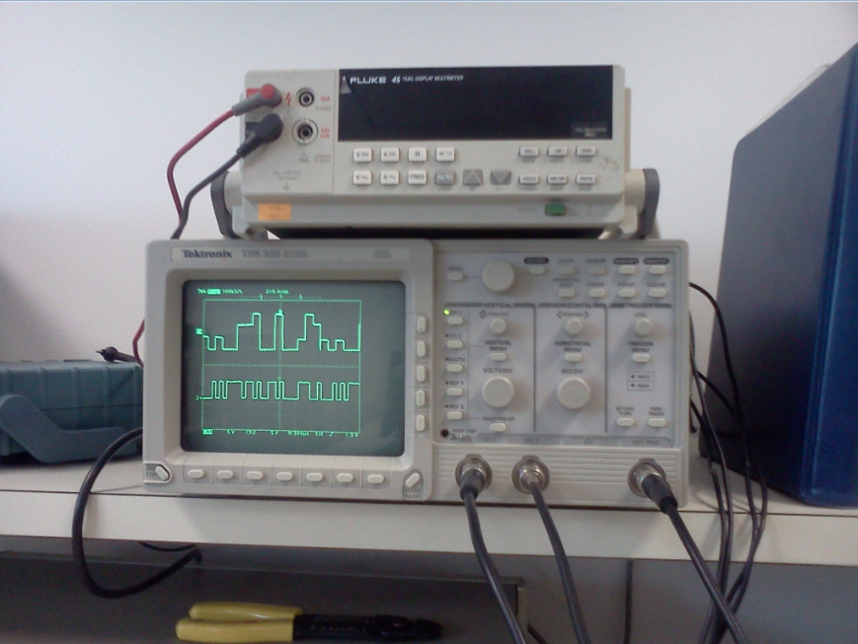

This is a screenshot displaying the data sequence along with the modulated sequence in XY mode display.

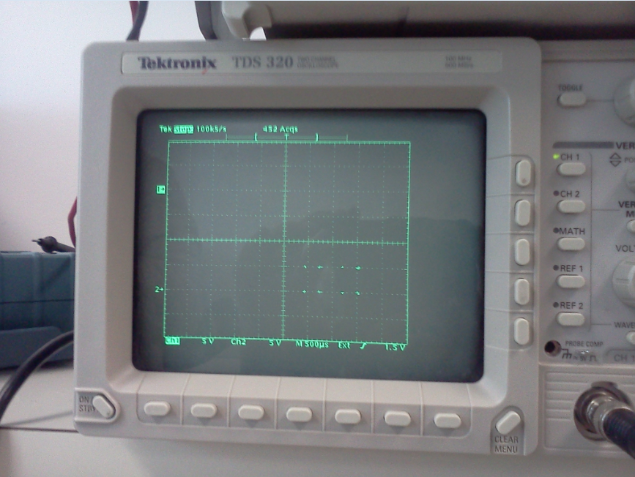

1. Include your wiring diagram in your write-up.

Wiring:

* Blue cables are Q.
* Red cables are everything before separating the signal.
* Yellow cables are I.
* Black cables go to scope selector.
* Channel 2 is original signal.
* Channel 1 is multilevel signal.

## Receiver

1. Use the lab manual to demodulate the signal. Write down the block diagram of how to demodulate the mQAM signal. Follow the wiring well by following the bellow diagram and skipping the modules that are crossed from the below screenshot.

Cables diagram followed, modules crossed were not used in this part of the lab.

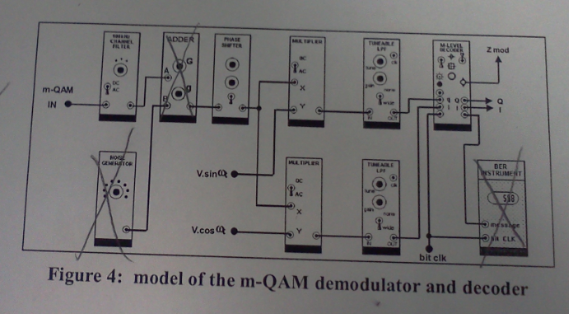

Channel 1 is multilevel and Channel 2 is original signal.

Here is a screenshot of the wiring up the cables to TIMS.

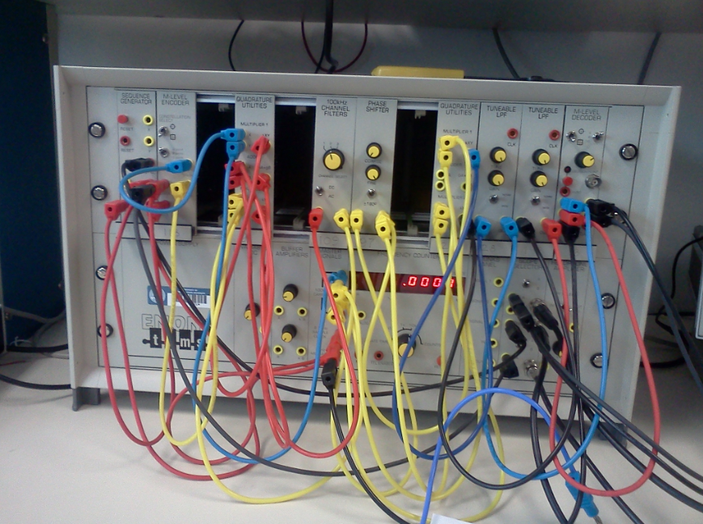

1. Display a diagram of the original data compared to the reconstructed data. Point out the correlation between the two signals.

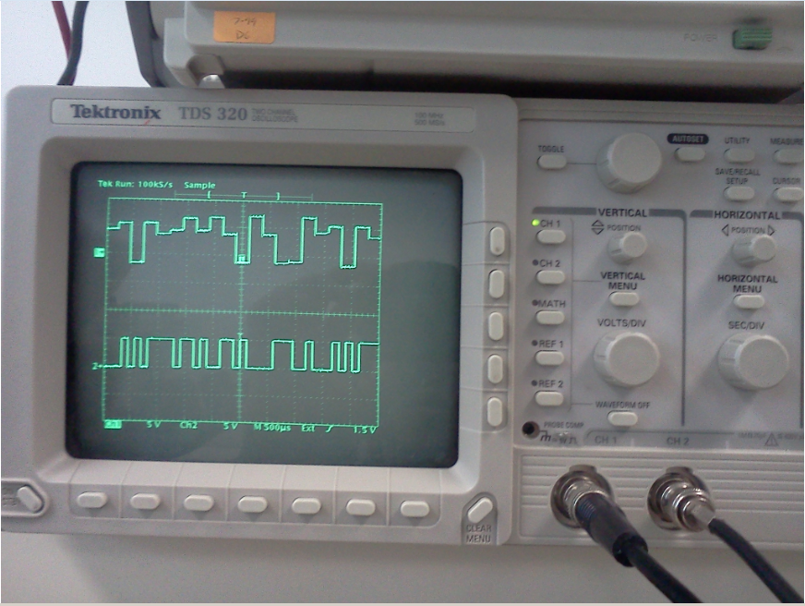

As I see the above screenshot, I see that the original and multilevel signals are related with a few differences such as phase and amplitude. Channel 1, represented by red arrow, and is representing the multilevel encoded signal. Channel 2, represented by blue arrow, and is representing the original signal.

1. Connect I and Q signals from the decoder and print off the signal constellation. Adjust the phase and see what the constellation does. On the phase shifter module try to make several adjustments and observe the oscilloscope for different results.

This is a screenshot of Cables set-up.

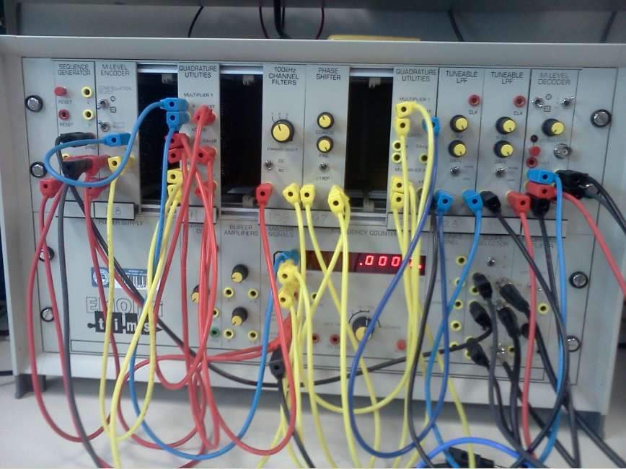

This is a screenshot showing the constellation formation as I adjusted the phase.

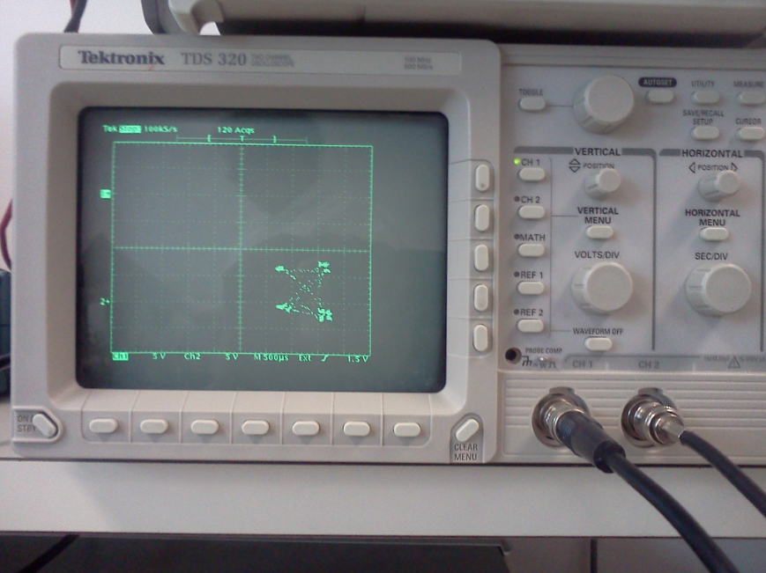

# Equipment Used

* Emona Tims equipment model 301- Manufacture: Emona Instruments:
  + Sequence Generator Module
  + M-Level Encoder Module
  + M-Level Decoder Module
  + 100 Channel Filter Module
  + Tunable LPF Module (x2)
  + Phase Shifter Module
  + Quadrature Utilities Module (2x)
  + Or Multiplier (4x) and Adder Modules
  + Adder Module
  + Noise Generator Module
* Oscilloscope: Tektronix TDS 210
* Cables
* TIMS Manual:
  + Multi-Level QAM & PSK

# Questions

How did you take into consideration the phase shift for modulation in the transmitter and demodulation in the receiver?

I used the sine and cosine signal waves to modulate transmission of Q and “I”. I then inverted them to demodulate them.

What are advantages of using QAM in comparison to just Amplitude Modulation for digital signals? Disadvantages?

Advantages:

The Q and I are separated by 900, changed the send signal and then combining them together. Also the modulated waves are summed, and the resulting waveform is a combination of both phase-shift keying and amplitude-shift keying.

Disadvantages:

Using QAM in comparison to Amplitude Modulation for digital signals are that the process for it is more complex, and there could be a bigger margin of errors.

# Report

As I completed this lab I have learned about QAM and how it is both an analog and a digital modulation scheme. It sends two analog message signals, or two digital bit streams, by modulating the amplitudes of two carrier waves, using the amplitude-shift keying digital modulation scheme or amplitude modulation analog modulation scheme. The two carrier waves, usually sinusoids, are out of phase with each other by 90° and are quadrature carriers. (http://en.wikipedia.org/wiki/Quadrature_amplitude_modulation)

The modulated waves are summed, and the resulting waveform is a combination of both phase-shift keying and amplitude-shift keying. In the digital QAM case, a finite number of at least two phases and at least two amplitudes are used. PSK modulators are often designed using the QAM principle. QAM is used extensively as a modulation scheme for digital telecommunication systems. Spectral efficiencies of 6 bits/s/Hz can be achieved with QAM. (http://en.wikipedia.org/wiki/Quadrature_amplitude_modulation)

By going through his lab I have learned how to send the 2 signals to create the modulated signal as well as getting the original signal to the oscilloscope as to observe the differences. This lab requires special attention when wiring to the TIMS device because if a single cable is inserted on the wrong slot then lab results may be as expected, it took me a few attempts to get it right.

With the QAM the modulated waves are summed, and the resulting waveform is a combination of both phase-shift keying and amplitude-shift keying.

# Conclusion

This lab has reinforced me the importance in using QAM, the One signal is called the “I” signal, and the other is called the “Q” signal. Mathematically speaking, one of the signals can be represented by sine wave, and the other by cosine wave. The two modulated carriers are combined at the source for transmission. (http://techforum4u.com/showthread.php/7144-Why-QAM-is-superior-to-ASK-and-PSK)

At the destination, the carriers are separated, the data is extracted from each, and then the data is combined into the original modulating information. Square m-QAM is normally easier to generate and demodulate than m-PSK, as m-QAM can simply be formed from two orthogonal ASK signals, whereas in m-PSK, one needs angle detection etc. (http://techforum4u.com/showthread.php/7144-Why-QAM-is-superior-to-ASK-and-PSK)

In the IT profession I believe it is important to know the many different ways we can send signals most efficiently, and this lab has taught me another way to do so. By learning different ways to send signals I will be able to be skilled in the IT field.

# References

Lab 12: <http://it327.groups.et.byu.net/>

Lab manual: <http://it327.groups.et.byu.net/files/Fall2010/Lab%2012%20-20Lab%20Manual.pdf>

QAM: <http://en.wikipedia.org/wiki/Quadrature_amplitude_modulation>

QAM superiority: <http://techforum4u.com/showthread.php/7144-Why-QAM-is-superior-to-ASK-and-PSK>

**Name: Lehi Alcantara**

**Completion Date: 11/22/2011**